

**SYNOPSIS OF PREDICTION OF LOAN APPROVAL**

**Prediction of Loan Approval**



**SUBMIT TO**

**Sumit Jaswal**

**30272**

**Assistant Professor**

**PYTHON**

|  |  |  |
| --- | --- | --- |
| **PREPARED BY** | | |
| **STUDENT’S NAME** | **ROLL NUMBER** | **REGISTRATION NO.** |
| EKHLAKH AHMAD | RD2215B58 | 12209166 |
| SUKHDEEP KAUR | RD2215B57 | 12209123 |

Lovely Professional University, Punjab(India)

**Prediction of Loan Approval by using Machine Learning**

ABSTRACT: -Banks are making major part of profits through loans. Though lot of people are applying for loans, it’s hard to select the genuine applicant, who will repay the loan. While doing the process manually, lot of misconception may happen to select the genuine applicant. Therefore, we are developing loan prediction system using machine learning, so the system automatically selects the eligible candidates. This is helpful to both bank staff and applicant.

# INTRODUCTION: -

Loan approval is a very important process for banking organizations. The system approved or reject the loan applications. Recovery of loans is a major contributing parameter in the financial statements of a bank. It is very difficult to predict the possibility of payment of loan by the customer.

Machine Learning technology are very useful in predicting outcomes for large amounts of data.

EXISTING SYSTEM:- Bank employees check the details of applicant manually and give the loan to eligible applicant. Checking the details of all applicants takes lot of time. The artificial neural network model for predict the credit risk of a bank. The Feed- forward back propagation neural network is used to forecast the credit default. The method in which two or more classifiers are combined together to produce a ensemble model for the better prediction. They used the bagging and boosting techniques and then used random forest technique.

PROPOSED SYSTEM: - To deal with the problem, we developed automatic loan prediction using machine learning techniques. We will train the machine with previous dataset. so, machine can analyse and understand the process. Then machine will check for eligible applicant and give us result

ARCHITECTURE TECHNIQUES: **-** Decision tree algorithm in machine erudition how’s which efficiently performs both family and retrogression tasks. It creates decision trees. Decision trees are universally used in the banking assiduousness due to their high exactitude and culpableness to formulate a statistical model in plain language. In Decision tree each knot represents a criterion (diagnostic), each link (branch) represents a decision (rule) and each chip represents an outcome (categorical or continues value).

## FUNCTIONALREQUIREMENTS

* Data Collection
* Data Preprocessing
* Training and Testing
* Modeling
* Predicting

## Step 1: Data Collection

Gather a dataset that includes historical loan application data. This dataset should contain features like applicant's age, income, credit score, loan amount, loan term, employment history, and loan approval status (approved or denied). Ensure that the dataset is diverse and representative of the population you're trying to make predictions for.

## Step 2: Data Preprocessing

Clean and preprocess the dataset to prepare it for machine learning. This may include:

Handling missing data (impute or remove).

Encoding categorical variables (one-hot encoding or label encoding).

Scaling numerical features (e.g., using StandardScaler or Min-Max scaling).

Splitting the data into training and testing sets (typically 70-80% for training and 20-30% for testing).

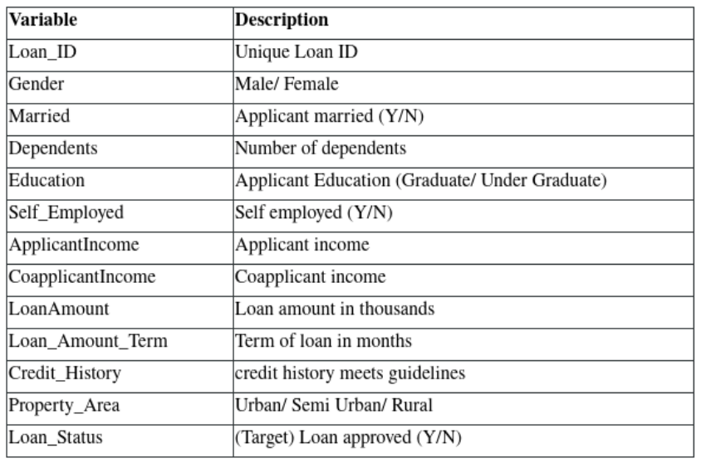

## Step 3: Exploratory Data Analysis (EDA)

Conduct EDA to gain insights into your data. Generate graphs and figures to visualize the relationships between variables. Some common EDA tasks include:

Histograms and box plots for numerical variables.

Bar plots and pie charts for categorical variables.

Correlation matrices and heatmaps to identify feature relationships.

Scatter plots to visualize the relationship between features and the target variable (loan approval).

## Step 4: Feature Selection/Engineering

Identify the most relevant features for your loan approval prediction. You can use techniques like feature importance from tree-based models, Recursive Feature Elimination (RFE), or domain knowledge to select the best features. You may also create new features if they can add predictive power.

## Step 5: Model Selection

Choose a machine learning model that is suitable for binary classification tasks like logistic regression, decision trees, random forests, gradient boosting, or support vector machines (SVMs). Experiment with multiple algorithms to find the one that performs best on your data.

## Step 6: Model Training and Evaluation

Train your selected model on the training dataset and evaluate its performance on the testing dataset. Use evaluation metrics such as accuracy, precision, recall, F1-score, and ROC-AUC to assess model performance. Visualize results using confusion matrices and ROC curves.

## Step 7: Hyperparameter Tuning

Optimize the model's hyperparameters using techniques like grid search or random search to find the best combination of hyperparameters that improve model performance.

## Step 8: Interpretability

Depending on the model selected, interpretability might be important. Techniques like SHAP (SHapley Additive exPlanations) values or feature importance plots can help explain model decisions.

## Step 9: Reporting and Visualization

Create a comprehensive report that includes:

Detailed analysis of the dataset, including summary statistics.

Visualizations from the EDA phase.

Model performance metrics and evaluation results.

Feature importance or coefficients if applicable.

Insights into which factors influence loan approval.

Recommendations for improving loan approval rates.

## Step 10: Deployment

Once satisfied with your model's performance, deploy it in a production environment where it can make real-time loan approval predictions.

## NON-FUNCTIONAL REQUIREMENTS

* Usability requirement
* Serviceability requirement
* Manageability requirement
* Recoverability requirement
* Security requirement
* Data Integrity requirement
* Capacity requirement
* Availability requirement
* Scalability requirement

## ADVANTAGES OF NON-FUNCTIONAL REQUIREMENT

* The nonfunctional requirements ensure the software system follow legal and compliance rules.
* They ensure the reliability, availability, and
* performance of the software system
* They ensure good user experience and ease of operating the software.
* They help in formulating security policy of the software system.

## DISADVANTAGES OF NON-FUNCTIONAL REQUIREMENT

* Nonfunctional requirement may affect the various
* high-level software subsystem
* They require special consideration during the software architecture/high-level design phase which increases.
* costs.
* Their implementation does not usually map to the
* specific software sub- system,
* It is tough to modify non-functional once you pass the
* architecture phase.

